Git Challenges
1.Resolve Merge Conflicts
A merge conflict occurs when Git cannot automatically merge changes because:
•Same file edited in same lines in two branches
•File deleted in one branch but modified in another
•Rebase or merge with overlapping commits
➢Attempt the merge
$git checkout main
$git merge feature-branch
If a conflict occurs:
➢Check conflicted files
$git status
➢Open the conflicted file
•Git marks conflicts like this:
<<<<<<< HEAD
Code from main branch
=======
Code from feature-branch
>>>>>>> feature-branch
➢Resolve the conflict manually
Choose one or combine both
Remove all conflict markers (<<<<, ====, >>>>)
➢Mark as resolved
$git add .
➢Complete the merge
$git commit -m “Message”
➢Push changes (if required)
$git push origin main
➢Resolving conflicts during rebase
$git rebase main
➢Fix the conflicts-→then:
$git add .
$git rebase --continue
➢Abort rebase:
Git rebase --abort
•Pull changes frequently
•Avoid large commits
•Communicate before editing shared files
•Prefer git pull --rebase
2 Create a merge conflict intentionally (two users editing the same line
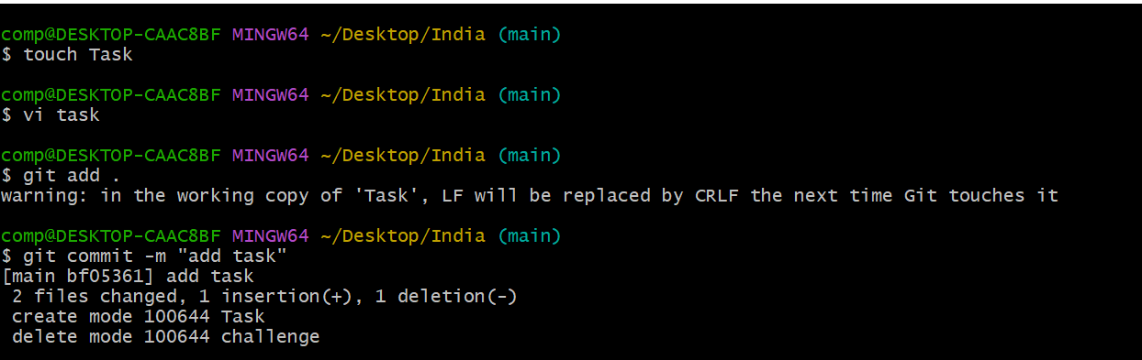
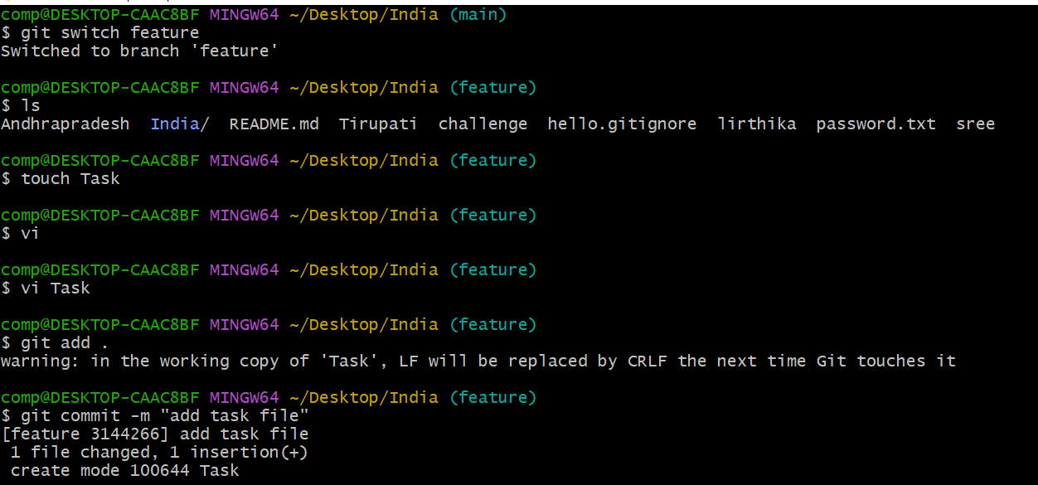
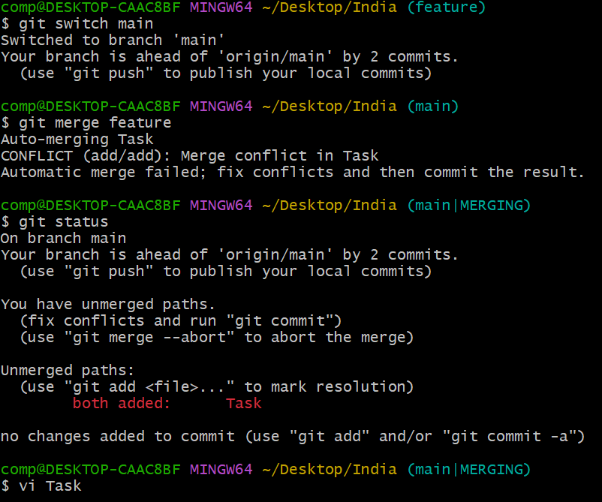
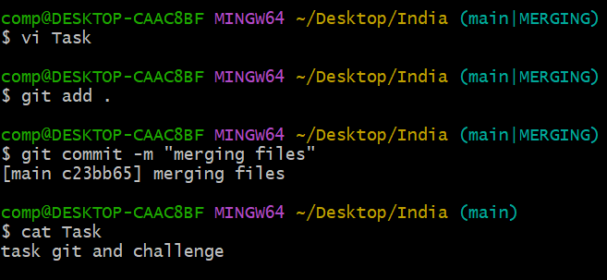
3 Resolve the conflict and push the changes.
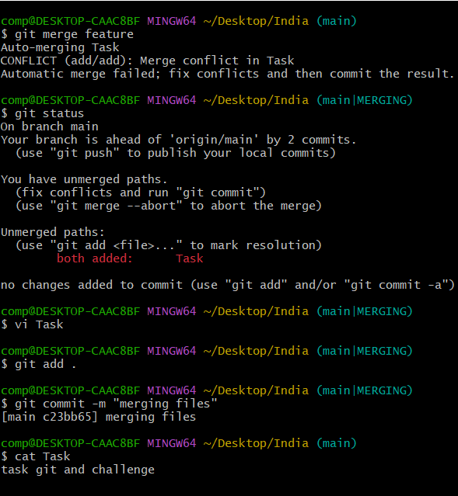
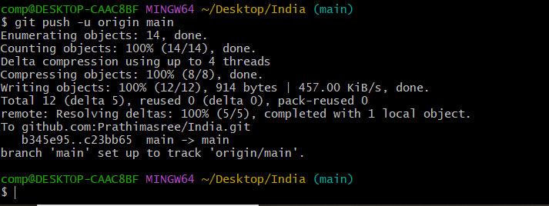
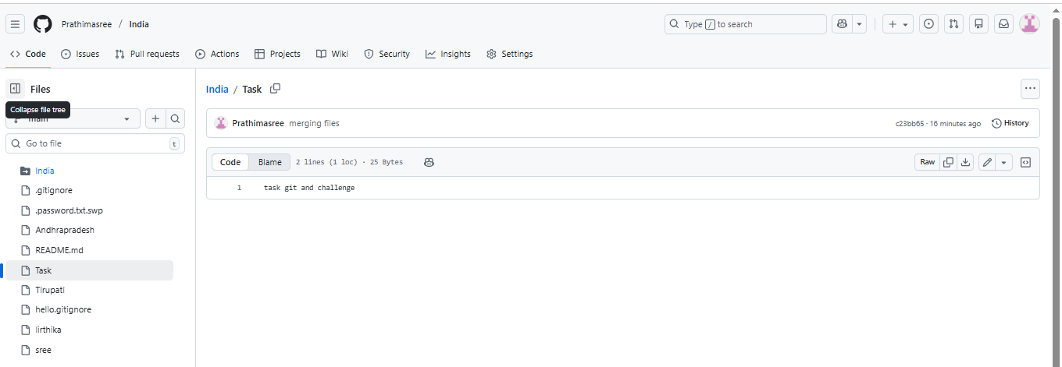
4.Recover Deleted Branch

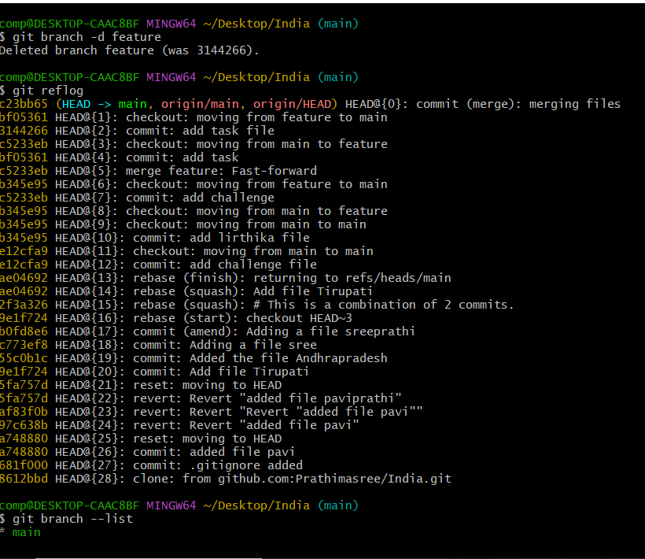
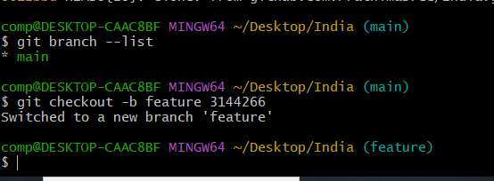
5.Delete a local branch and then recover it using the reflog
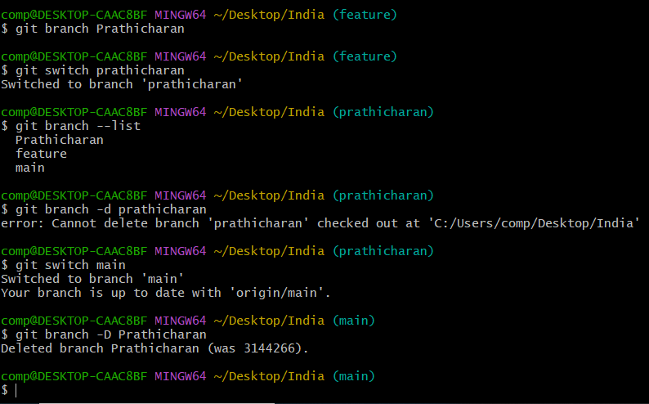
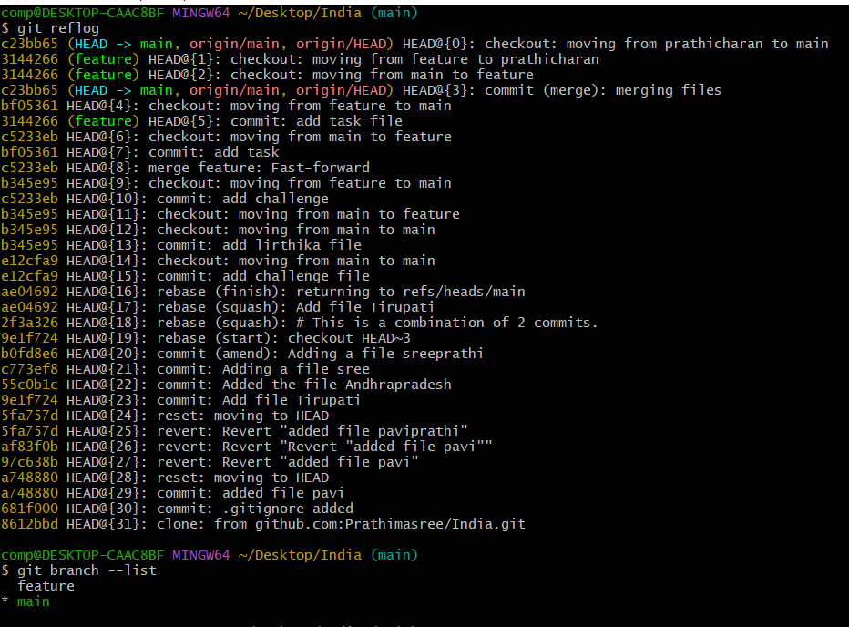
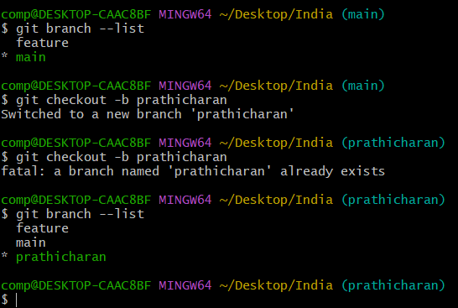
6.Undo Wrong Push
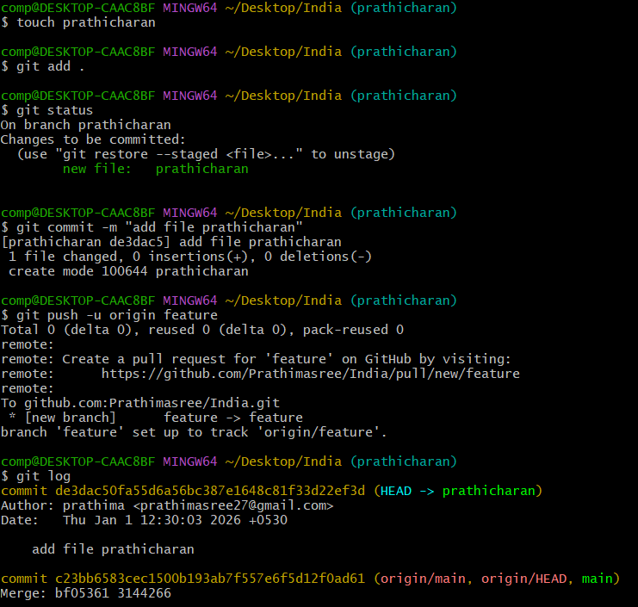
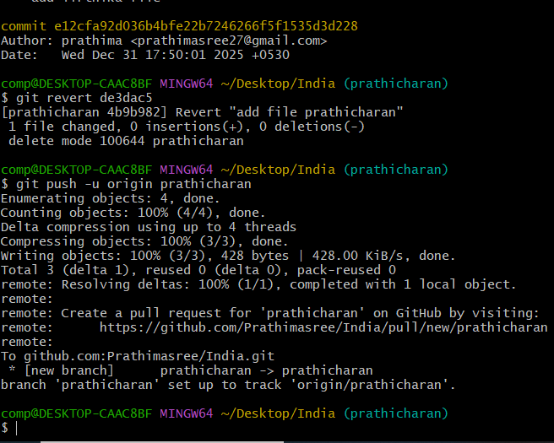
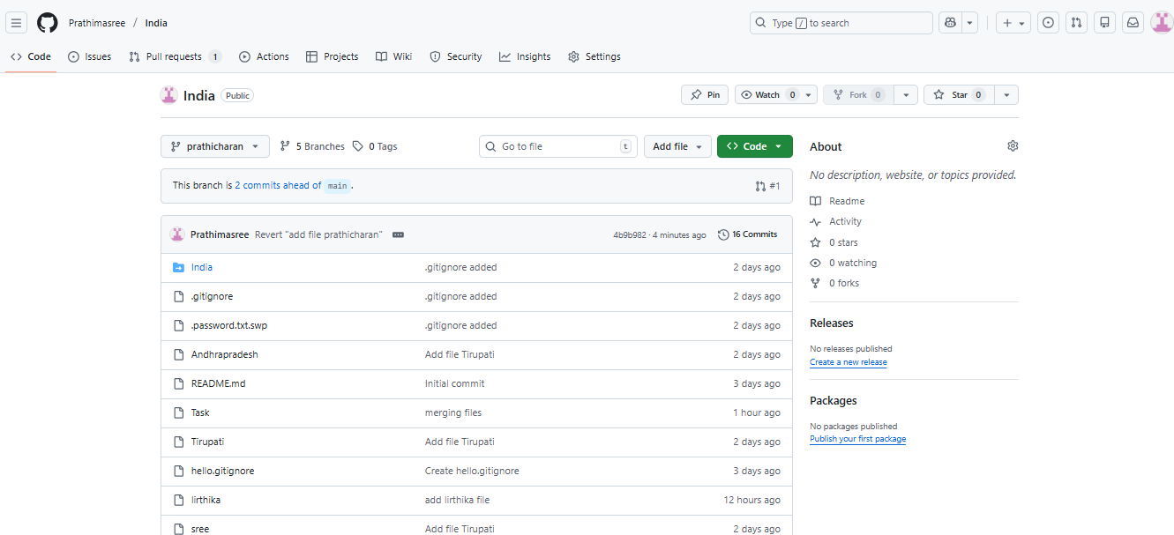

7.Push a wrong commit to GitHub, then undo it without losing history.

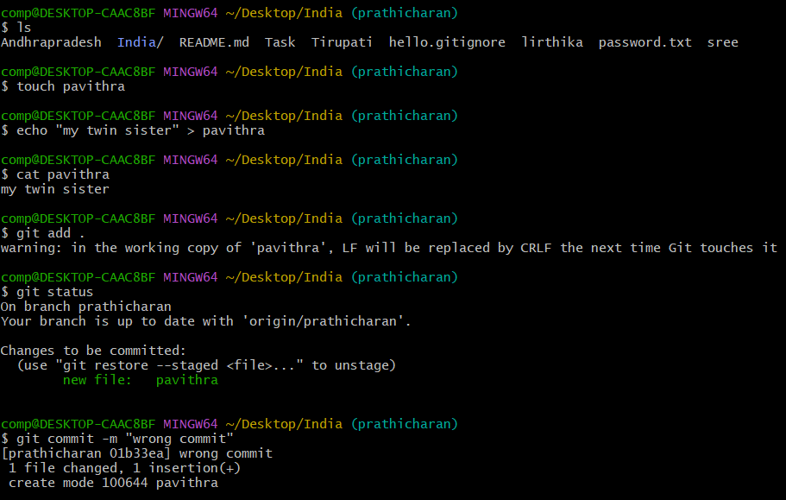
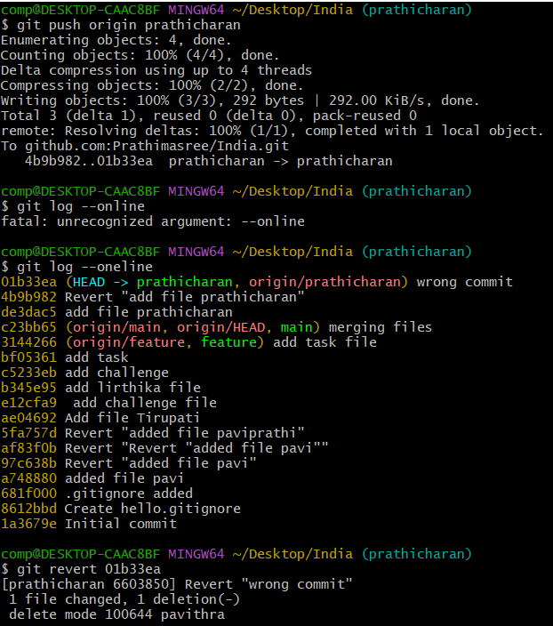
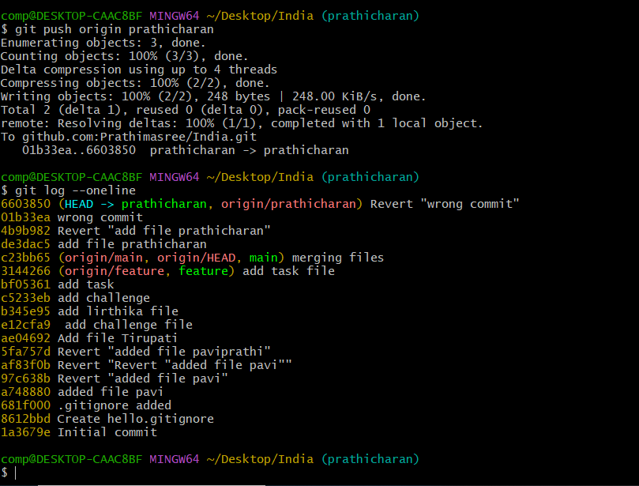
Amend a Commit
1.Make a commit, then add a missing file to it using
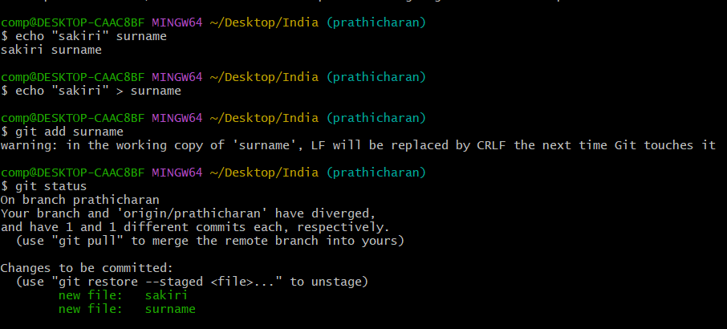
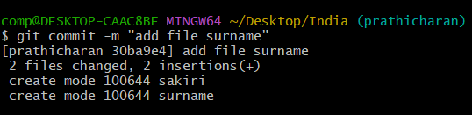
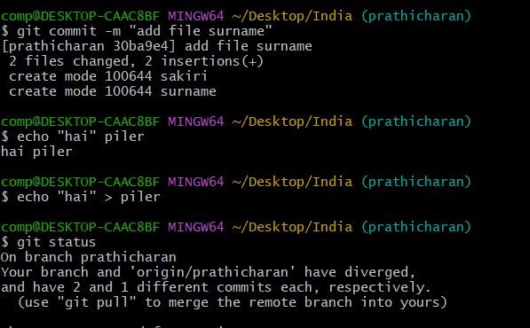
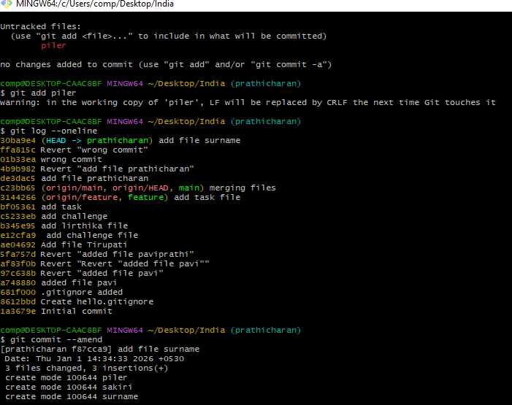
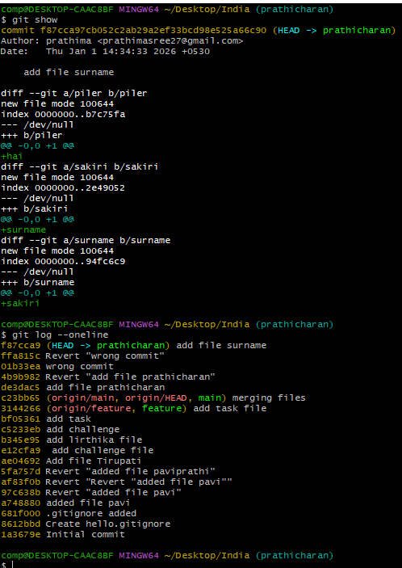
2.Cherry-pick a Commit
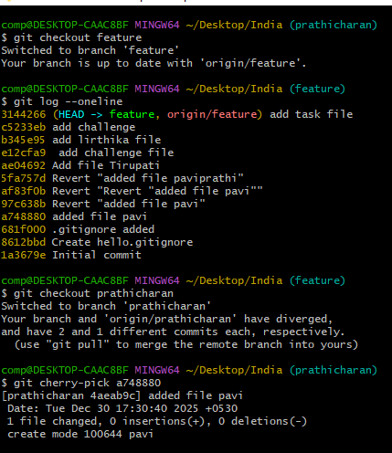
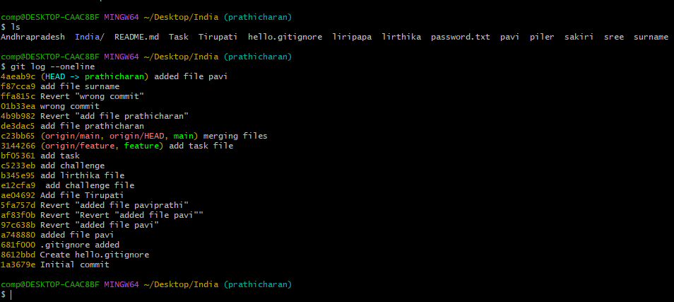
3.Take a specific commit from one branch and apply it to another branch.
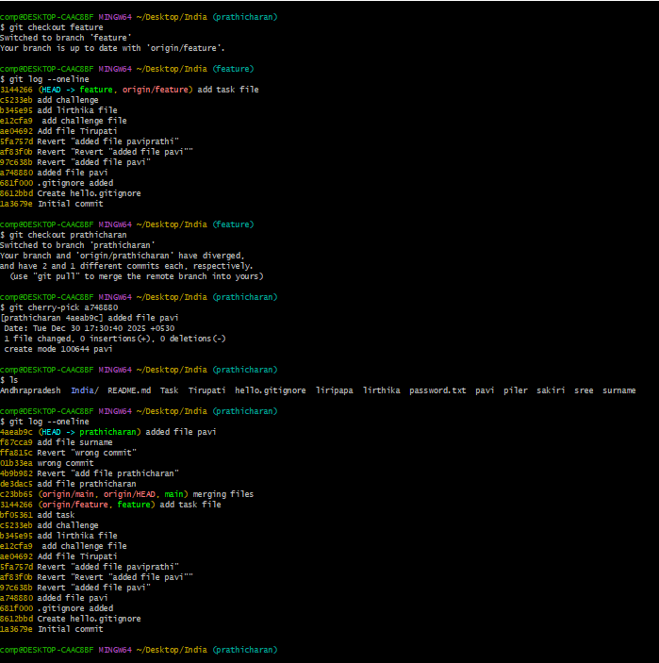
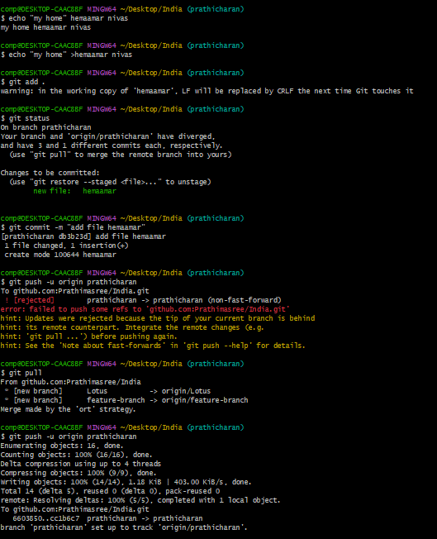
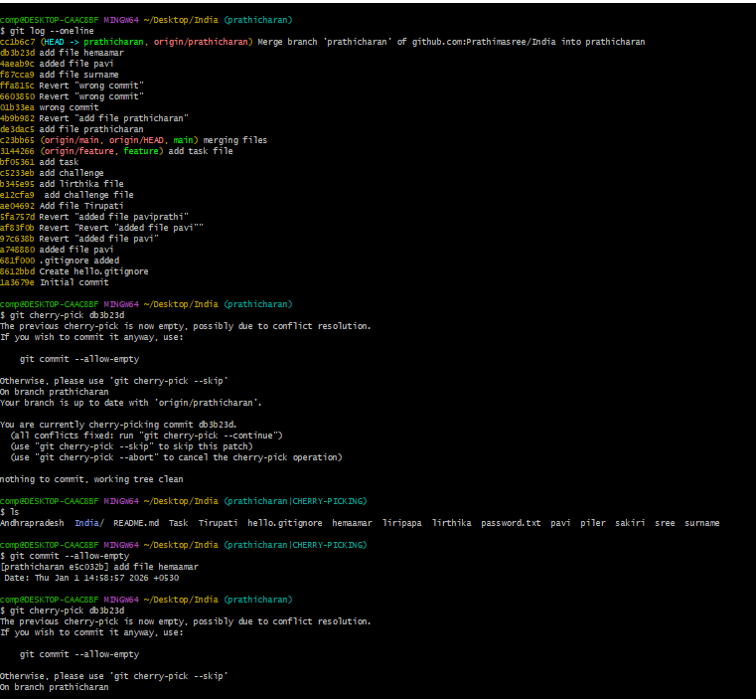
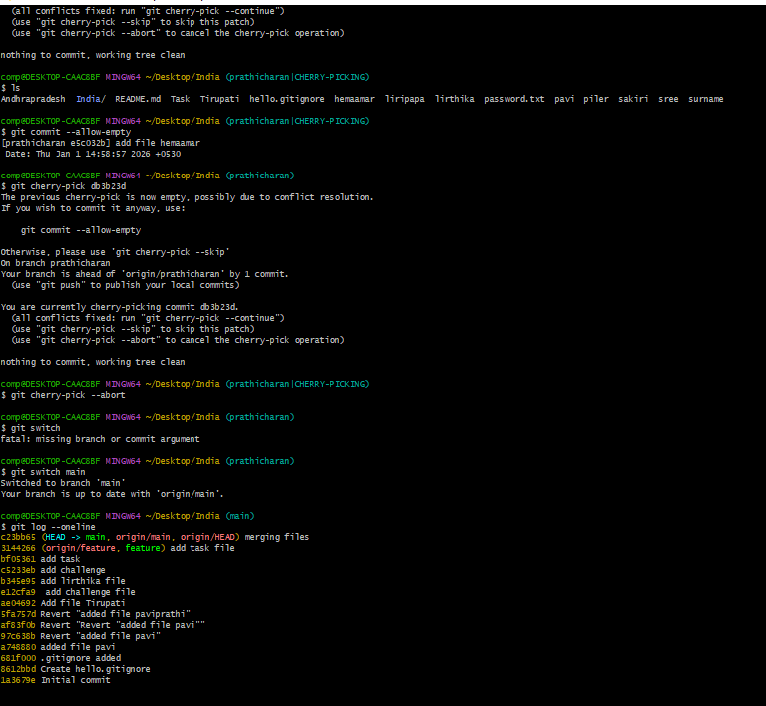
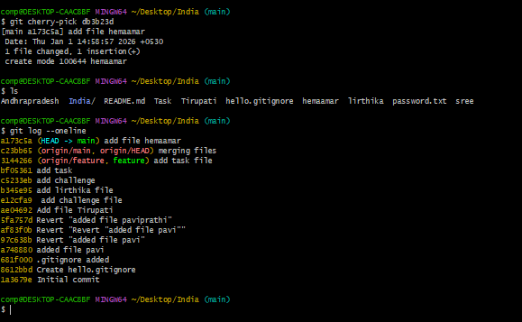
4.Interactive Rebase
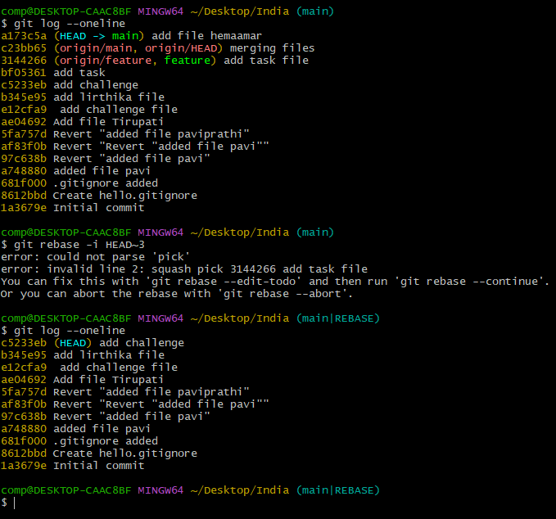
5. Reorder and squash multiple commits into a single clean commit.
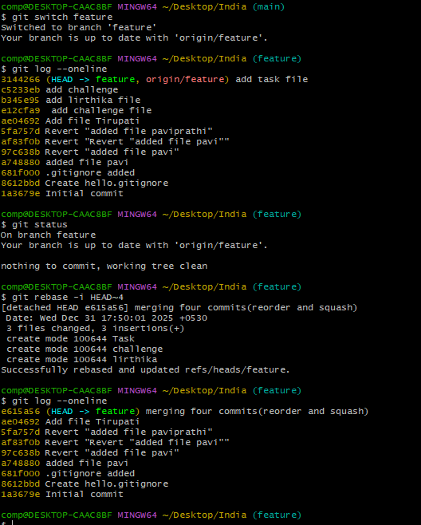
6.Tagging & Release
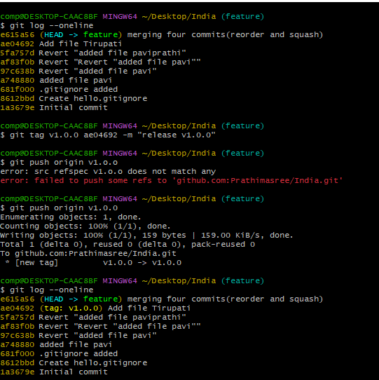
7.Create a version tag (v1.0), push it to GitHub, then delete and restore it.
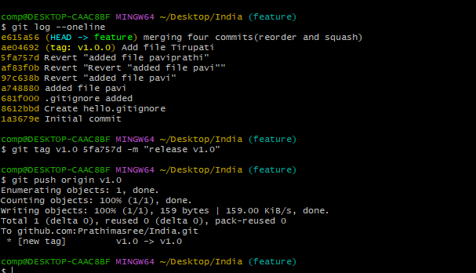
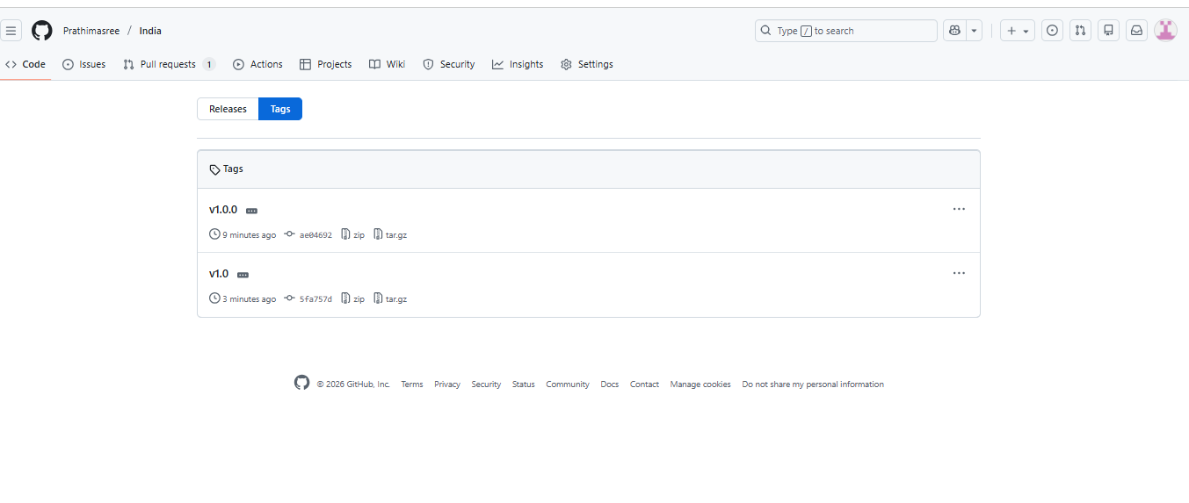
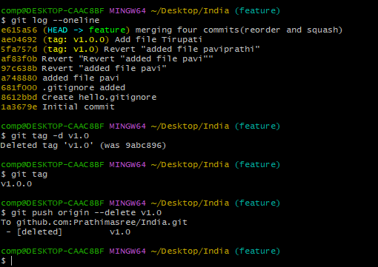
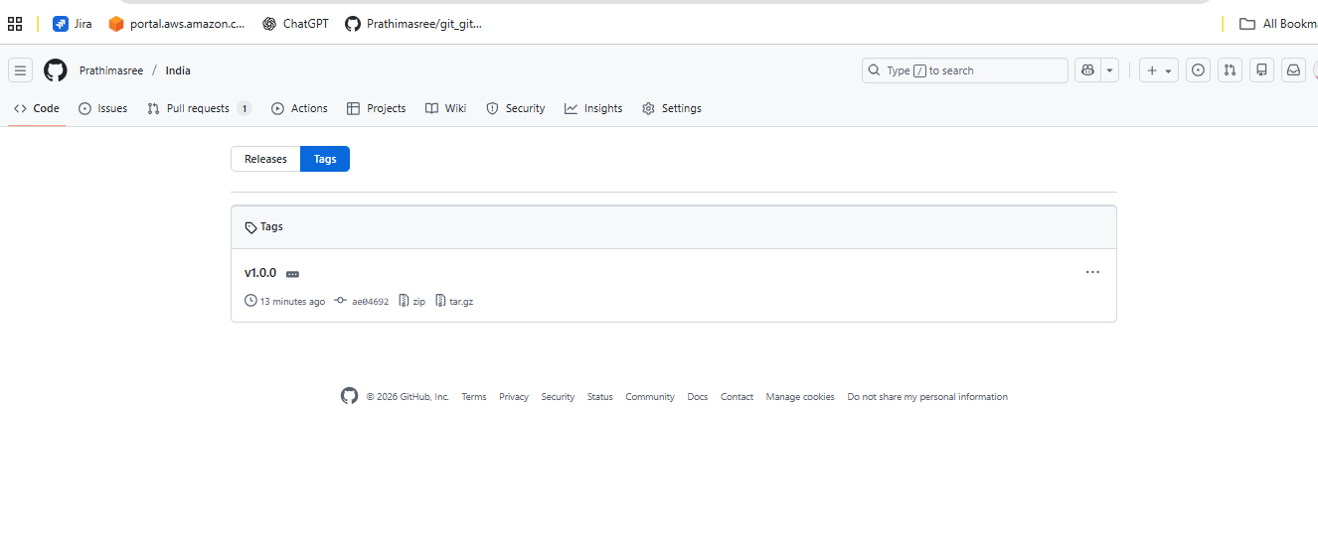

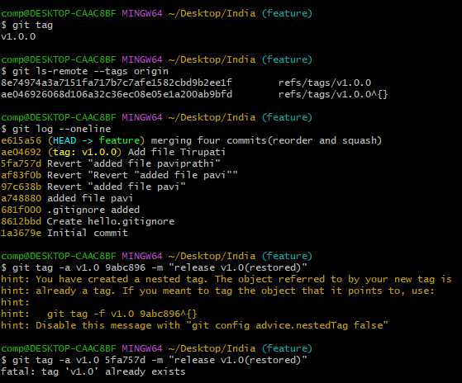
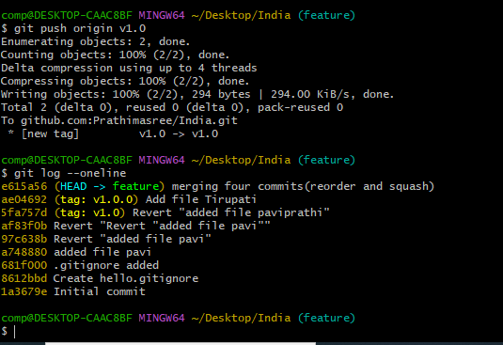
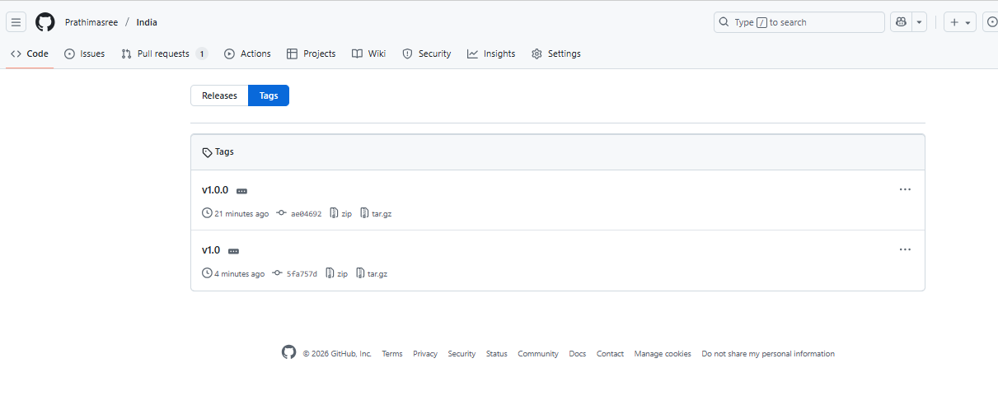
- Clone with Sparse Checkout
- Sparse checkout lets we clone a repository but check out only specific folders/files, not the entire repo. This is very useful for large repositories.
- When to Use Sparse Checkout
• Repo is very large
• You only need one folder/module
• Faster clone, less disk usage
- Sparse checkout allows checking out only specific files or directories
from a Git repository instead of the entire project.

- Clone only a subdirectory of a repo using sparse checkout.
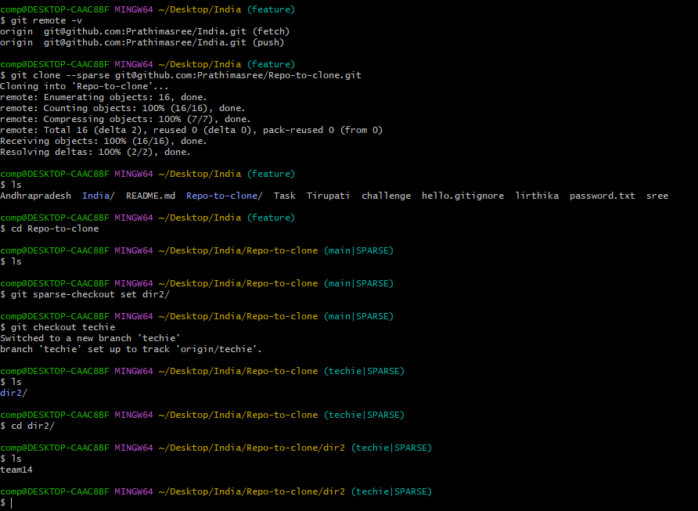
Reset vs Revert Challenge
1.Demonstrate the difference between git reset --hard and git revert in a repo.
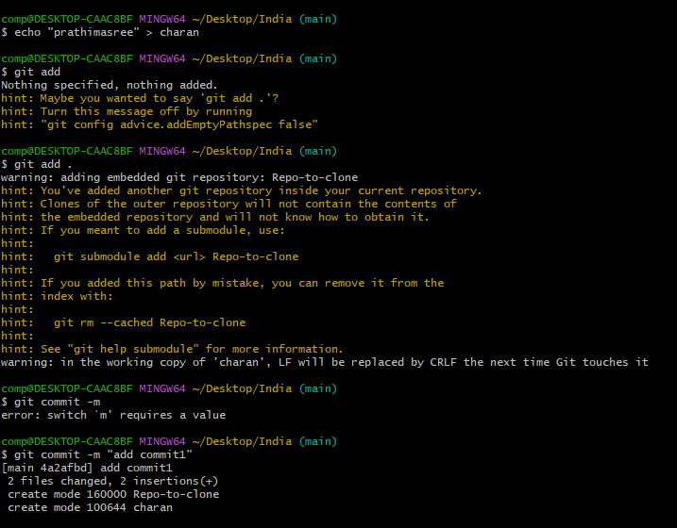
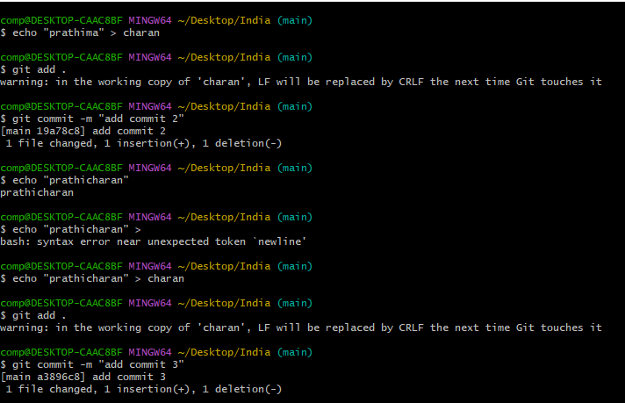
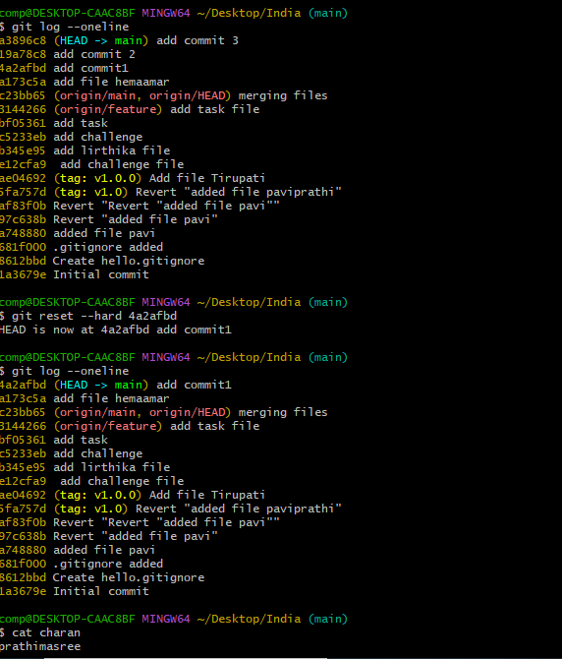
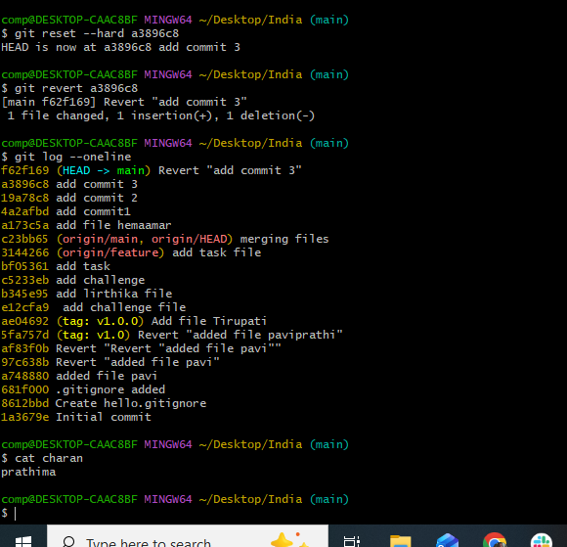
2.Detached HEAD Challenge
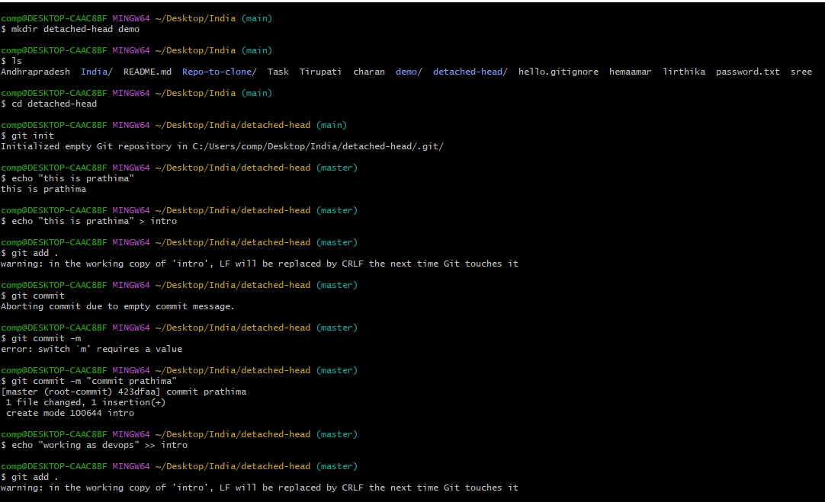
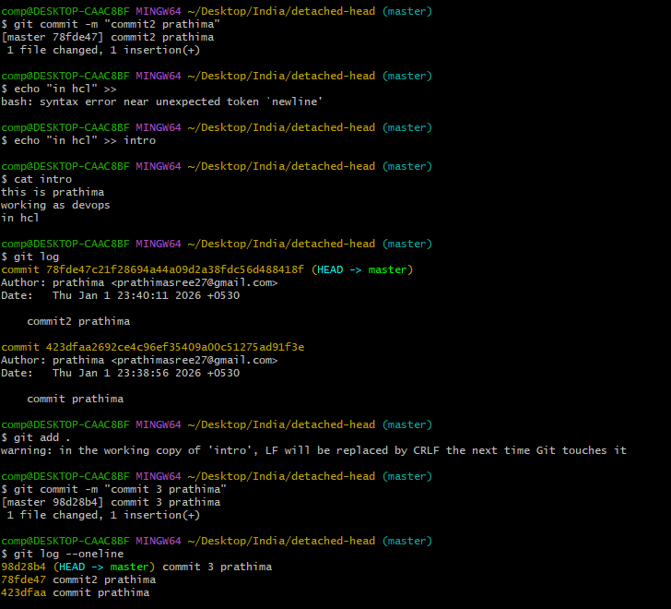
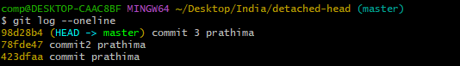
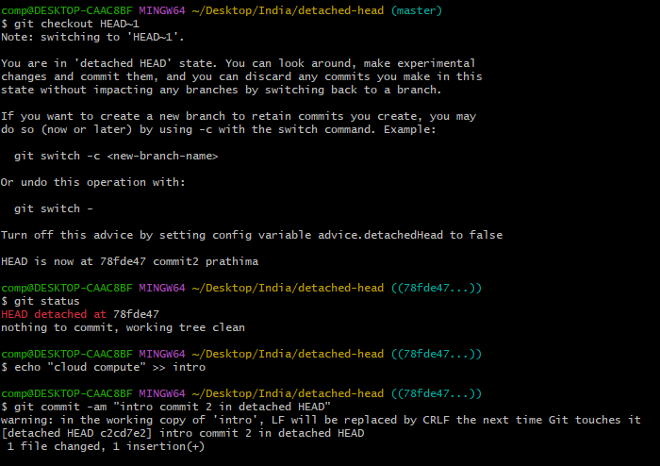
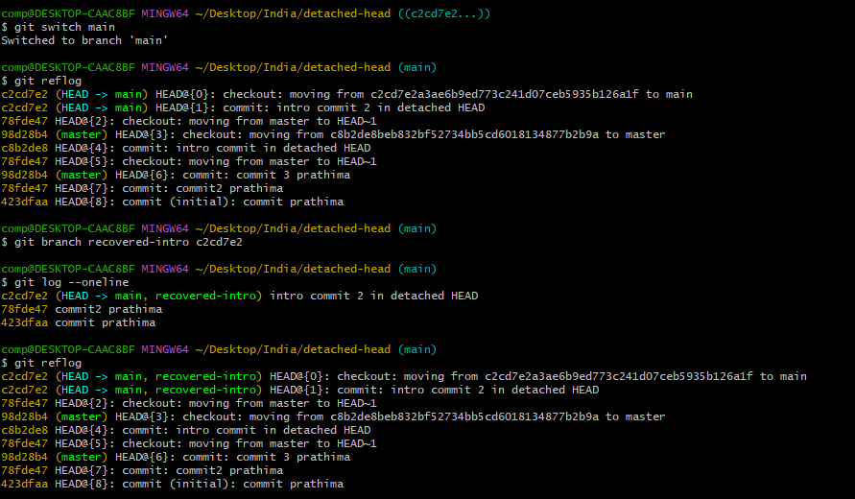
3.Checkout a specific commit (detached HEAD state) and create a new branch from it.
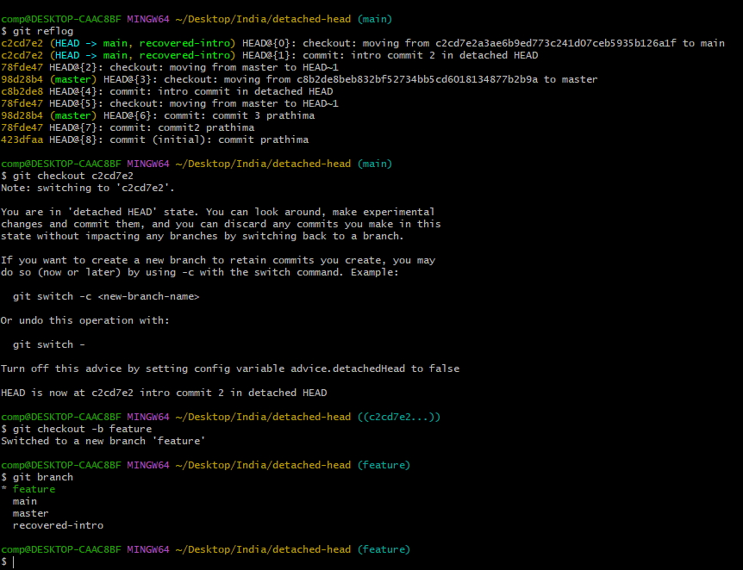
Git Hooks Challenge
- Configure a pre-commit hook to reject commits without a message format (e.g., must start with JIRA-XXX).
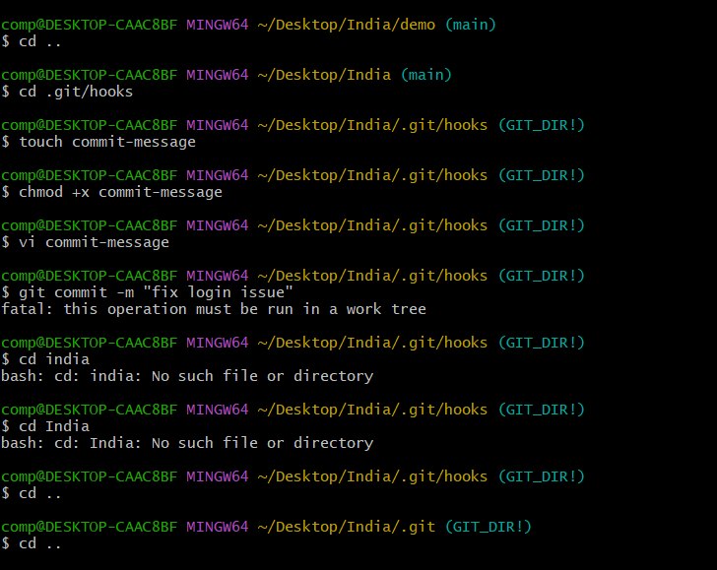
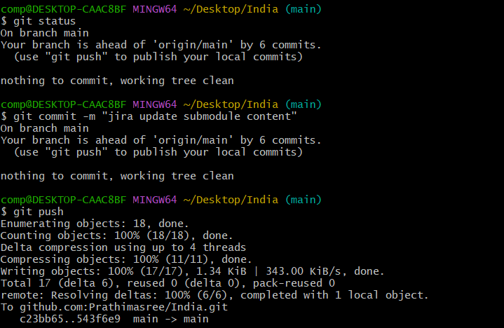
2.Squash Merge vs Rebase Merge

- Squash and Merge combines all feature branch commits into one commit on the main branch, creating a clean, single-point entry for the feature, ideal for simple project history.
- Rebase and Merge rewrites history by moving feature commits on top of the main branch's latest, creating a linear, cleaner history without extra merge commits but alters original commits.
Squash and Merge
· What it does:
Takes all commits from a feature branch and squashes them into a single, new commit on the target branch (e.g., main).
· History:
Very clean and linear; the main branch only sees one commit for the entire feature.
· Best for:
Keeping the main branch history tidy, consolidating many small, messy commits (like "fix typo," "oops") into one meaningful change.
· Drawback:
Loses granular history of individual commits within the feature branch.
Rebase and Merge (or just Rebase)
· What it does:
Replays your feature branch commits one-by-one onto the tip of the main branch, making it seem like you started from the latest main. Then, you typically merge (often a fast-forward).
· History:
Creates a perfectly linear history, as if all work happened sequentially on the main branch.
· Best for:
A single-developer or small team workflow where a pristine, linear history is paramount, making it easier to follow the flow of changes.
· Drawback:
Rewrites commit history, which can be problematic if the branch is shared; also presents conflicts commit-by-commit
Standard Merge (For Comparison)
· What it does:
Combines the branches by creating a new "merge commit" that ties the histories together.
· History:
Preserves the exact history of both branches, showing exactly when they diverged and merged.
· Best for:
Large teams or complex projects where complete, unaltered history is crucial for auditing and understanding development flow.
· Drawback:
Can create a cluttered, nonlinear history with many merge commits.
3.Show the difference between squash merge and rebase merge with evidence.
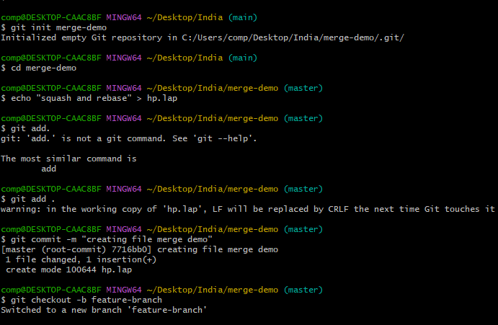
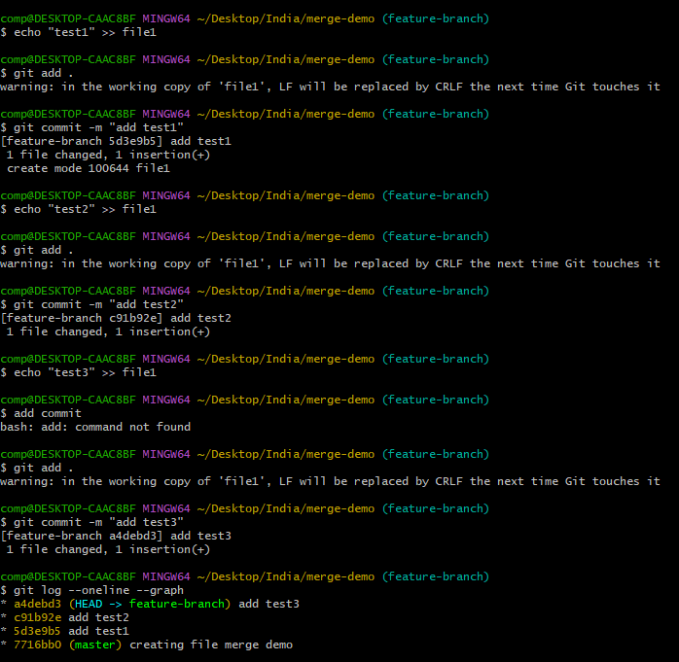
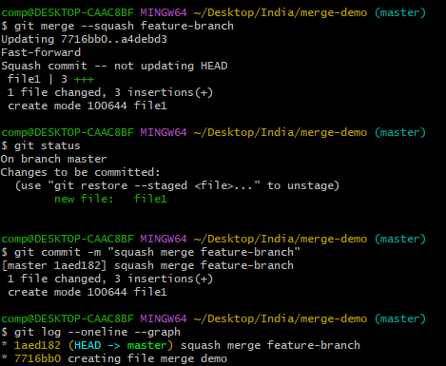
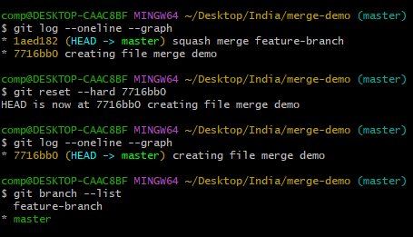
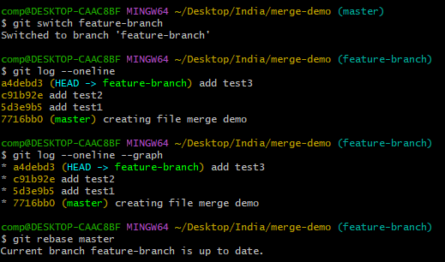
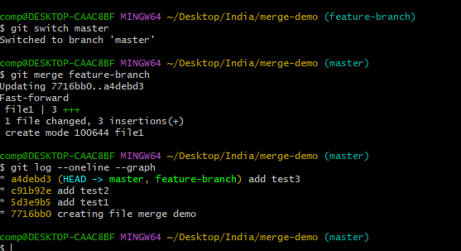
4.Fork & Pull Request Workflow
You don’t have write access to the original repo
• You contribute via your own fork
• Changes are proposed using a Pull Request
• Upstream repo → Original project (owner’s repo)
• Fork → Your copy of the repo
• Local repo → Your machine
• Pull Request → Request to merge your changes
5.Fork a repo, make a change, and submit a pull request to the original repo.

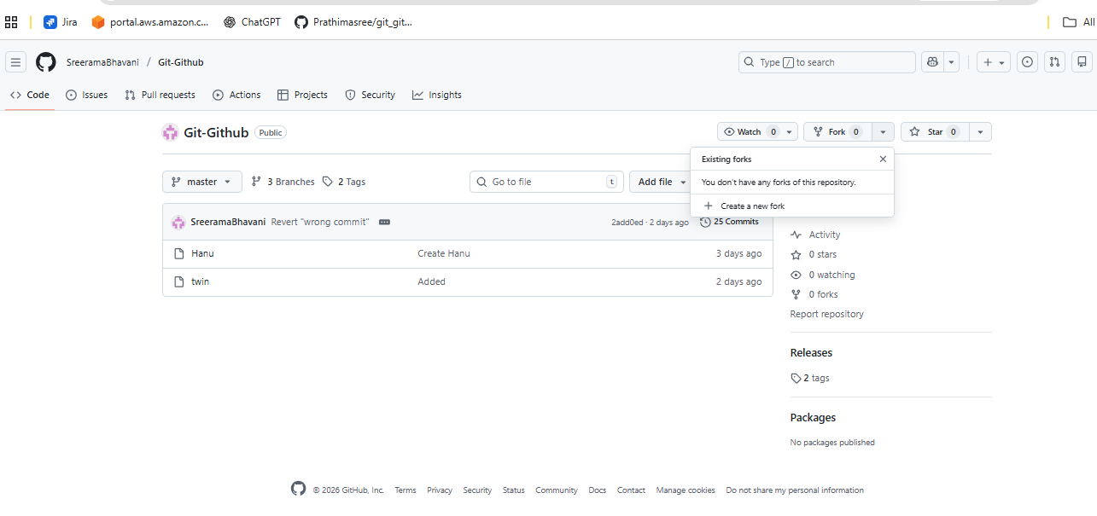
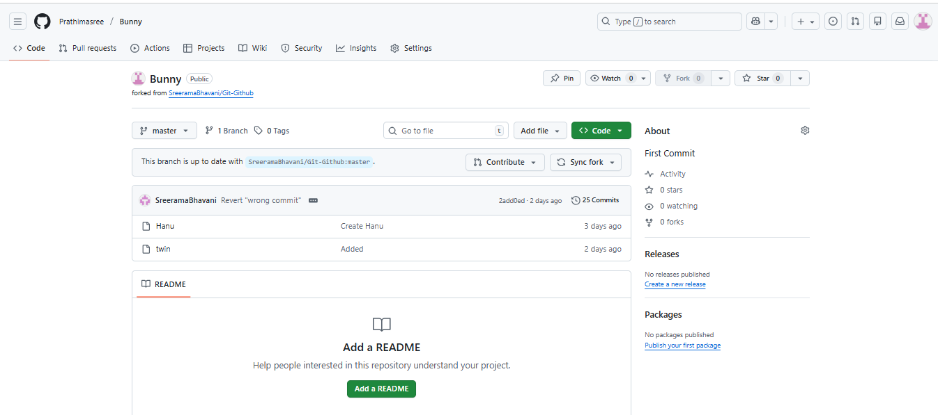
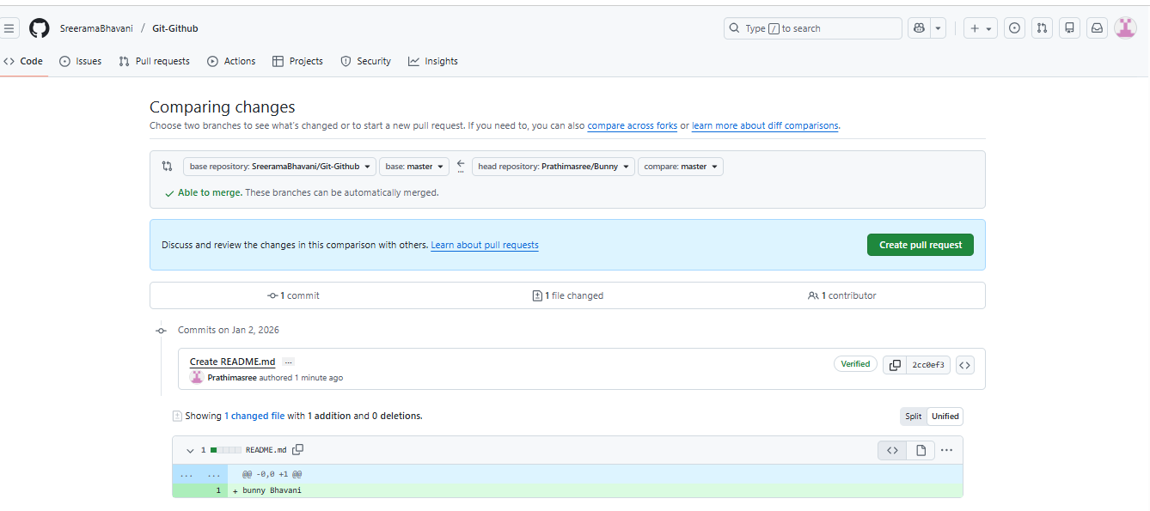
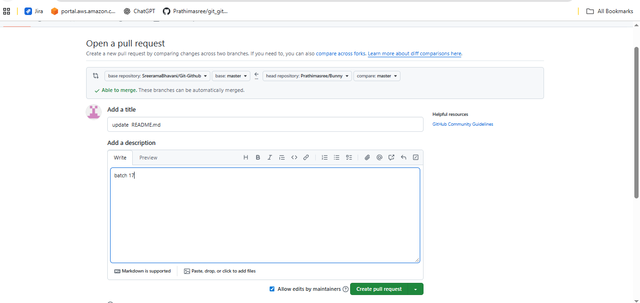
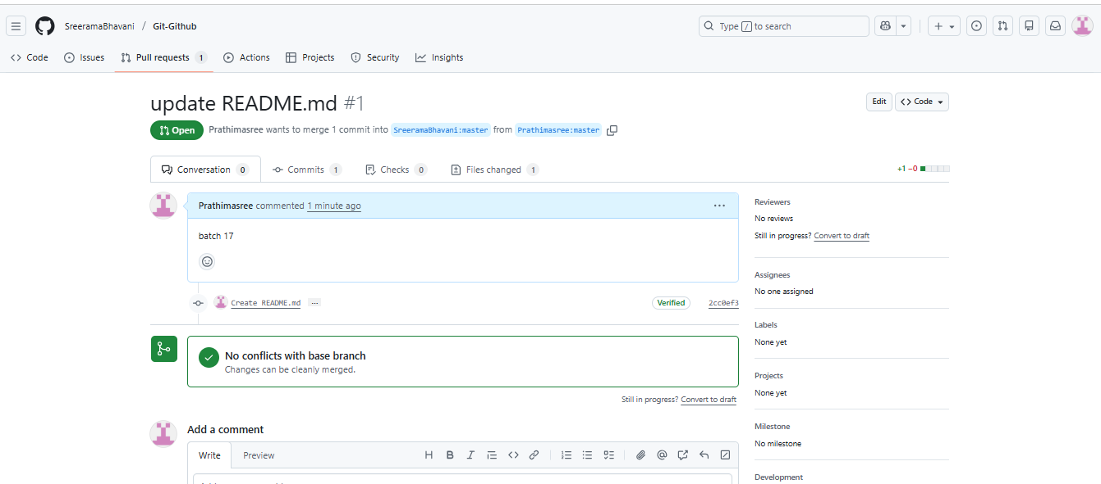
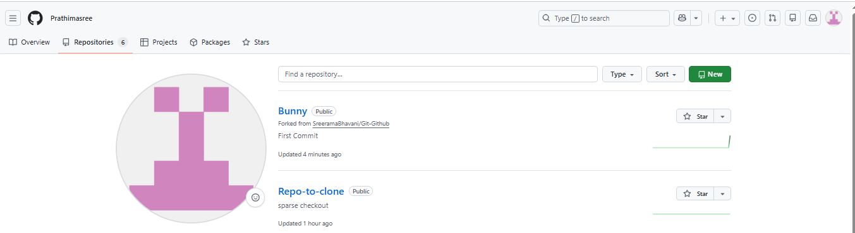
Recover Lost Commit
1.Commit something, reset hard, and then recover it using git reflog
